**Object Oriented Programming**



**Lab Report #1**

|  |  |
| --- | --- |
| Name | Ali Salman |
| Reg no | FA22-BCE-005 |
| Class | BCE- 4 |
| Instructor’s Name | Prof. Tayyab Rasul |

**Lab 01: *Review of Basic Programming Concepts***

**Lab Tasks:**

1. Write a program that declares a structure to store book Id, price and pages of a book. The structure should include functions to assign user defined values to each book and display the record of most costly book.

**Program:**

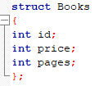

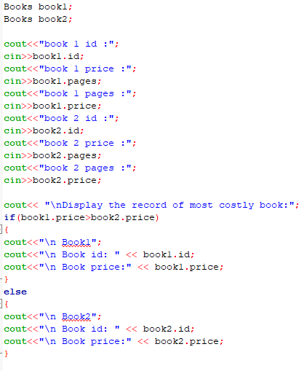

**Output:**

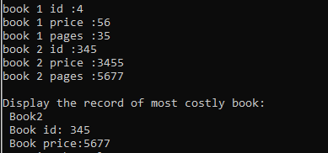

1. Write a program to take the values of two integers and use pointers to add 10 to the value of each integer.

**Program:**

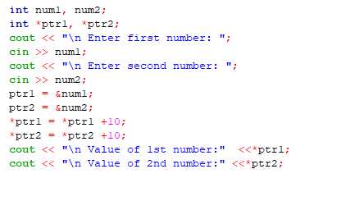

**Output:**

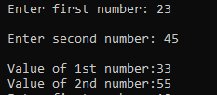

1. Write a function that swaps the values of two integer variables
2. using pass by value

**Program:**

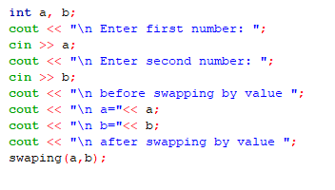

**Function:**

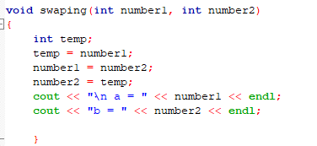

**Output:**

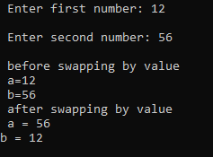

1. and pass by reference and see their differences

**Program:**

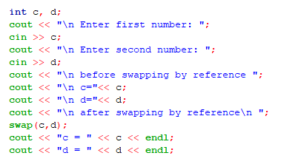

**Function:**

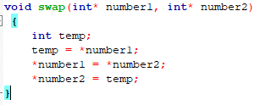

**Output:**

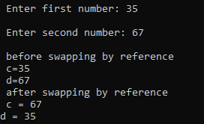

**Home Tasks:**

1. There is a structure called **employee** that holds information like employee code, name, date of joining. Write a program to create an array of the structure and enter some data into it. Then ask the user to enter current date. Display the names of those employees whose tenure is 3 or more than 3 years according to the given current date.

**Program:**

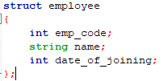

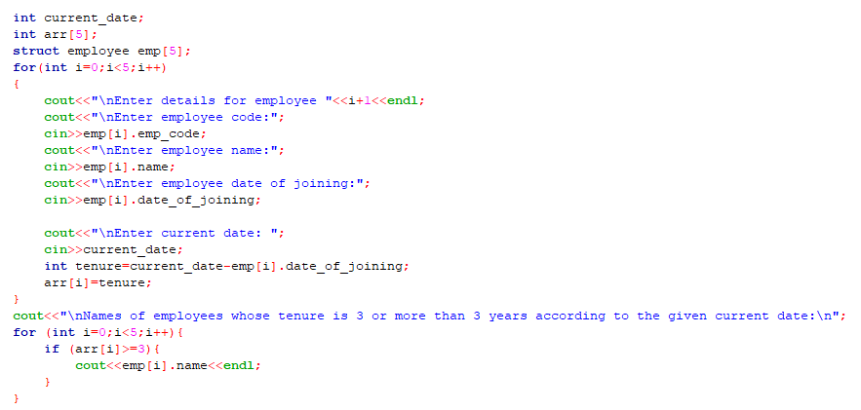

**Output:**

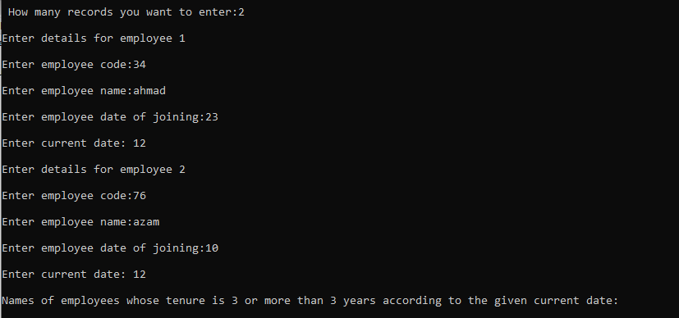

1. Write a function to sort data (in increasing order) in an array using
2. pass by value

**Program:**

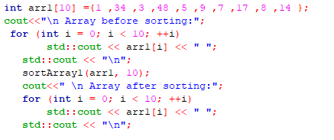

**Function:**

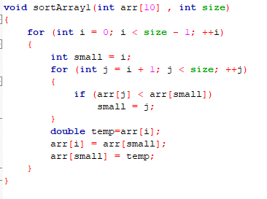

**Output:**

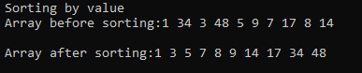

1. and pass by reference.

**Program:**

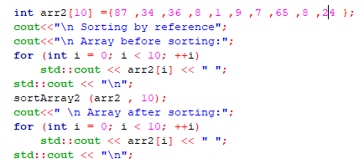

**Function:**

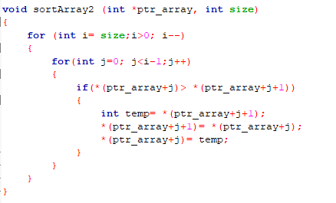

**Output:**

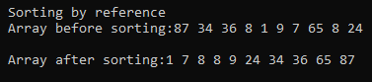

1. Write a program that inputs a string value from the user and displays it in reverse using pointer.

**Program:**

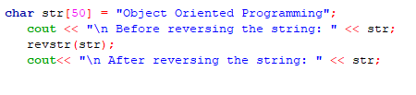

**Function:**

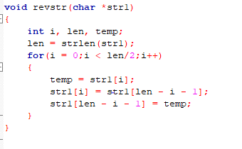

**Output:**



**Critical Analysis:**

In this lab, we revise the basic concepts of arrays, pointers, structures and functions. We learn the difference between passing a data item by value and by reference. Previously we have studied programming in C, now we have switch to C++. Thus, in this lab we got familiar to C++ syntax. We came to know that there is a slight difference in c and C++. C is a Procedure oriented language while C++ is Object oriented language but we can also write simple programs in C++.